Processes
- Process Concept
- Process Scheduling
- Operations on Processes
- Cooperating Processes
- Interprocess Communication
- Communication in Client-Server Systems
Process Concept
- An operating system executes a variety of programs:
  - Batch system – jobs
  - Time-shared systems – user programs or tasks
- Process – a program in execution; process execution must progress in sequential fashion
Process State
- As a process executes, it changes state
  - new: The process is being created
  - running: Instructions are being executed
  - waiting: The process is waiting for some event to occur
  - ready: The process is waiting to be assigned to a processor
  - terminated: The process has finished execution
Diagram of Process State
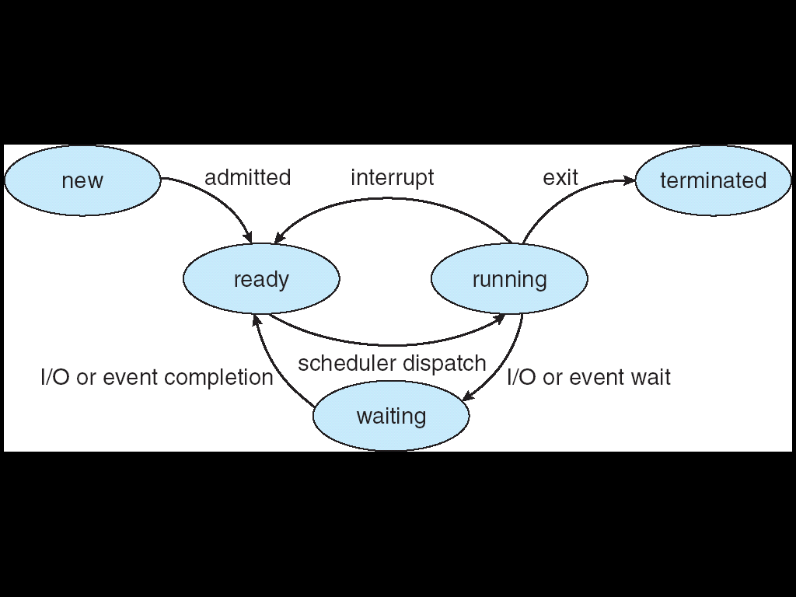

Process Control Block (PCB)
Information associated with each process
- Process state
- Program counter
- CPU registers
- CPU scheduling information
- Memory-management information
- Accounting information
- I/O status information
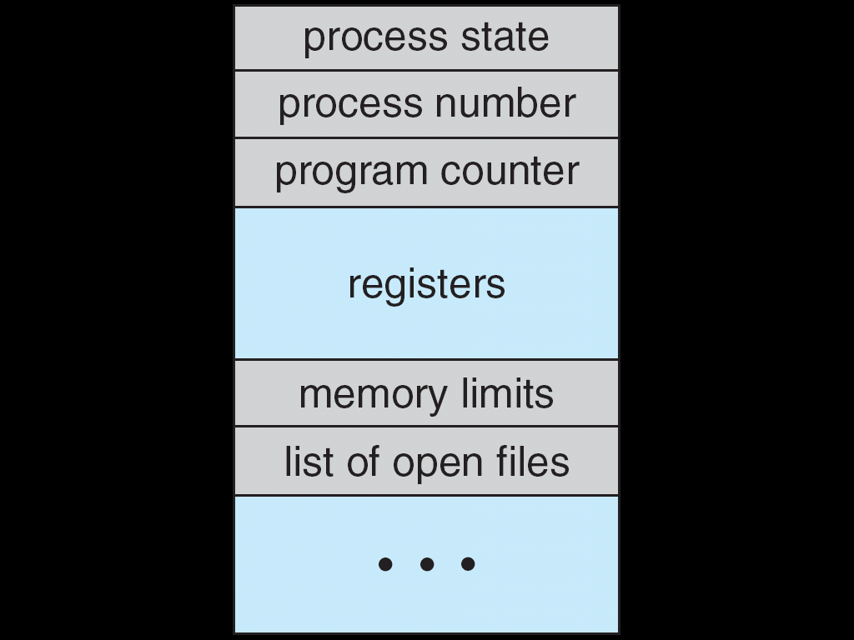
Process Control Block (PCB)

Process Scheduling Queues
- Job queue – set of all processes in the system
- Ready queue – set of all processes residing in main memory, ready and waiting to execute
- Device queues – set of processes waiting for an I/O device
Schedulers
- Long-term scheduler (or job scheduler) – selects which processes should be brought into the ready queue
- Short-term scheduler (or CPU scheduler) – selects which process should be executed next and allocates CPU
Schedulers (Cont.)
- Short-term scheduler is invoked very frequently (milliseconds) ⇒ (must be fast)
- Long-term scheduler is invoked very infrequently (seconds, minutes) ⇒ (may be slow)
- The long-term scheduler controls the degree of multiprogramming
Context Switch
- When CPU switches to another process, the system must save the state of the old process and load the saved state for the new process
- Context-switch time is overhead; the system does no useful work while switching
- Time dependent on hardware support
Process Creation
- Parent process create children processes, which, in turn create other processes, forming a tree of processes
- Execution
  - Parent and children execute concurrently
  - Parent waits until children terminate
- Address space
  - Child duplicate of parent
  - Child has a program loaded into it
Process Termination
- Process executes last statement and asks the operating system to delete it (exit)
  - Output data from child to parent (via wait)
  - Process’ resources are deallocated by operating system
- Parent may terminate execution of children processes (abort)
  - Child has exceeded allocated resources
  - Task assigned to child is no longer required
  - If parent is exiting
    - Some operating system do not allow child to continue if its parent terminates
      - All children terminated - cascading termination
Cooperating Processes
- Independent process cannot affect or be affected by the execution of another process
- Cooperating process can affect or be affected by the execution of another process
- Advantages of process cooperation
  - Information sharing
  - Computation speed-up
  - Modularity
  - Convenience
The Operating System and the Inter-Process Communication
- The O.S. provide the means for cooperating processes to communicate with each other.
- IPC facility provides two operations:
  - send(message) – message size fixed or variable
  - receive(message)
- If P and Q wish to communicate, they need to:
  - establish a communication link between them
  - exchange messages via send/receive
- Implementation of communication link
  - physical (e.g., shared memory, hardware bus)
  - logical (e.g., logical properties)
Direct Communication
- Processes must name each other explicitly:
  - send (P, message) – send a message to process P
  - receive(Q, message) – receive a message from process Q
- Properties of communication link
  - Links are established automatically
  - A link is associated with exactly one pair of communicating processes
  - Between each pair there exists exactly one link
  - The link may be unidirectional, but is usually bi-directional
Indirect Communication
- Messages are directed and received from mailboxes (also referred to as ports)
  - Each mailbox has a unique id
  - Processes can communicate only if they share a mailbox
- Properties of communication link
  - Link established only if processes share a common mailbox
  - A link may be associated with many processes
  - Each pair of processes may share several communication links
  - Link may be unidirectional or bi-directional
Buffering
- Queue of messages attached to the link; implemented in one of three ways
1. Zero capacity – 0 messages
Sender must wait for receiver (rendezvous)
2. Bounded capacity – finite length of n messages
Sender must wait if link full
3. Unbounded capacity – infinite length
Sender never waits

CPU Scheduling Techniques
Basic Concepts
- Maximum CPU utilization obtained with multiprogramming
- CPU–I/O Burst Cycle – Process execution consists of a cycle of CPU execution and I/O wait
- CPU burst distribution
CPU Scheduler
- Selects from among the processes in memory that are ready to execute, and allocates the CPU to one of them
- CPU scheduling decisions may take place when a process:
1. Switches from running to waiting state
2.Switches from running to ready state
3. Switches from waiting to ready
4. Terminates
- Scheduling under 1 and 4 is nonpreemptive
- All other scheduling is preemptive
Scheduling Criteria
- CPU utilization – keep the CPU as busy as possible
- Throughput – # of processes that complete their execution per time unit
- Turnaround time – amount of time to execute a particular process
- Waiting time – amount of time a process has been waiting in the ready queue
- Response time – amount of time it takes from when a request was submitted until the first response is produced, not output (for time-sharing environment)
Optimization Criteria
- Max CPU utilization
- Max throughput
- Min turnaround time
- Min waiting time
- Min response time
First-Come, First-Served (FCFS) Scheduling
Process Burst Time
P₁ 24
P₂ 3
P₃ 3
- Suppose that the processes arrive in the order: P₁ , P₂ , P₃
The Gantt Chart for the schedule is:

- Waiting time for
P₁ = 0; P₂ = 24; P₃ = 27
- Average waiting time:
(0 + 24 + 27)/3 = 17
FCFS Scheduling (Cont.)
Suppose that the processes arrive in the order
P₂ , P₃ , P₁
- The Gantt chart for the schedule is:

- Waiting time for
P₁ = 6; P₂ = 0; P₃ = 3
- Average waiting time:
(6 + 0 + 3)/3 = 3
- Much better than previous case
- Convoy effect short process behind long process

Shortest-Job-First (SJF) Scheduling
- Associate with each process the length of its next CPU burst. Use these lengths to schedule the process with the shortest time
Two schemes:
Non-preemptive – once CPU given to the process it cannot be preempted until completes its CPU burst
Preemptive – if a new process arrives with CPU burst length less than remaining time of current executing process, preempt. This scheme is know as the
Shortest-Remaining-Time-First (SRTF)
- SJF is optimal – gives minimum average waiting time for a given set of processes
Priority Scheduling
- A priority number (integer) is associated with each process
- The CPU is allocated to the process with the highest priority (smallest integer ≡ highest priority)
  - Preemptive
  - nonpreemptive
- Problem ≡ Starvation – low priority processes may never execute
- Solution ≡ Aging – as time progresses increase the priority of the process

Process Burst Time Priotrity
P₁ 24 1
P₂ 3 3
P₃ 3 ₂
Round Robin (RR)
- Each process gets a small unit of CPU time (time quantum), usually 10-100 milliseconds. After this time has elapsed, the process is preempted and added to the end of the ready queue.
- If there are n processes in the ready queue and the time quantum is q, then each process gets 1/n of the CPU time in chunks of at most q time units at once. No process waits more than (n-1)q time units.
- Performance
  - q large ⇒ FIFO
  - q small ⇒ q must be large with respect to context switch, otherwise overhead is too high
Example of RR with
Time Quantum = 20
Process Burst Time
P₁ 53
P₂ 17
P₃ 68
P₄ 24

HTML HYPERLINKS
- Hyperlinks allow a user to see specific parts of the Web pages or other pages that are linked to it. They allow the user to activate a particular part of the page and perform some actions.
- The actions performed by a hyperlink includes the ff:
- Moving to another of the same document
- Opening another document on the same web site
- Opening another document on a different web site
Types of Hyperlinks
- Internal Hyperlink
- this is any link that lets the user to navigate within a page, such as going to its top or bottom
2. External Hyperlink
- this is a link that brings a user to another web page, file, web site, new groups or any particular location in the www other than itself.
Elements of a Hyperlink
- Anchor Tag
  - This tag defines a hyperlink within or outside a web page. It has at least two components including
  - The text or image that is to be clicked to activate the link
  - The URL of the link’s which will be opened when the link is clicked
- Anchors are created in much the same way, but instead of using the HREF attribute in the <A> tag, you use the NAME attribute.
- Name attribute takes a keyword (or words) that will be used to name that anchor.
Internal Links
- Two steps to create a link in the same HTML document or to a specific location.
  - Select the text at a place in the document that you would like to create a link to, then add an anchor to link to like this:
<A NAME=“bookmark_name”>Book Mark</A>
- The NAME attribute of an anchor element specifies a location in the document that you will link to shortly. All NAME attributes in a document must be unique.
Internal Links
2. Next, select the text to create as a link to the location created. Add the following anchor around text link.
<A HREF=“#bookmark_name”>Goto Book Mark</A>

Elements of a Hyperlink
2. The HREF attribute
This attribute written right beside the anchor tag, is used to specify the specific the specific name of the link that is to be accessed
Use href attribute, short for “Hypertext Reference” is used to specify the name or URL of the file where this link points.
3. The TARGET attribute
This attribute is especially important when there is more than one frame in a page and the frame where
- An information is to be displayed needs to be specified
LINKING PAGES
- Text Hyperlinks
Hyperlinks are created using the anchor tag denoted by <A> and </A>.

*Tag should contain two components:
- The text (or image) that symbolizes the link.
- The URL of the actual resource.

Example
<HTML>
<HEAD>
<TITLE>Using Background Color</TITLE>
</HEAD>
<BODY>
<p>To see more about space exploration, click<A HREF=http://www.nasa.gov>NASA </A>.</p>
</body>
</HTML>
EXAMPLE 2
<HTML>
<HEAD>
<TITLE>Link to other Web Pages</TITLE>
</HEAD>
<BODY>
<H2>Link to other Web Page</H2>
<BR>
<A href=http://www.urs.edu.ph>

Example of External Hyperlink
<a href=“menu.html”>menu bar</a>
Link of an image
<html>
<body>
<p>Create a link of an image:
<a href=“doc1.html">
<img src=“tulips.jpg" alt="HTML tutorial" width="32" height="32" />
</a></p>
<p>No border around the image, but still a link:
<a href=“doc1.html">
<img border="0" src=“tulips.jpg" alt="HTML tutorial" width="32" height="32" />
</a></p>
</body>
</html>
Link to a Location on the same page
<html>
<body>
<p>
<a href="#C4">See also Chapter 4.</a>
</p>
<h2>Chapter 1</h2>
<p>This chapter explains ba bla bla</p>
<h2>Chapter 2</h2>
<p>This chapter explains ba bla bla</p>
<h2>Chapter 3</h2>
<p>This chapter explains ba bla bla</p>
<h2><a name="C4">Chapter 4</a></h2>
<p>This chapter explains ba bla bla</p>
</body>
</html>

FRAMES
- With frames, it is possible to create Web pages that look and feel entirely different from other Web pages – pages that have table of tables, banners, footnotes and sidebars, just to name a few common features frames can provide.
- Frames also changes what a “page” means to the browser and to the reader
- A frame is a single screen consists of a number of separate HTML documents that interact with each other.

- The first HTML document you need to create is called the frame definition document
- The frame definition document is the page that contains the layout of each frame and the names of the HTML documents that will fill that frame

<FRAMESET> TAG
- Use the <frameset> tag to create a frame definition document
- When used in an HTML document, the (frameset> tag replaces the <body> tag, as shown below:
<html>
<head>
<title>page title</title>
</head>
<frameset>
Your frame definition goes here
</frameset>
</html>
- A frameset is the set of frames defined by the <frameset> tags in the frame definition document.
COLS ATTRIBUTE
- If a <frameset> tag is define, you must include one of two attributes as part of the tag definition
- The cols attribute, which takes the following form:
<Frameset cols=“column width,column width,…”>
- The COLS attribute tells the browser to split the screen into a number of vertical frames whose widths are defined by column width values separated by commas.
- The width of each frame is defined in one of three ways:
  - Explicitly in pixels
  - As a percentage of the total width of the <frameset> or
  - With an asterisk (*)
example
<frameset cols=“100, 50%,*”>
</frameset>
ROWS ATTRIBUTE
- This attribute works the same as the COLS attribute, except that it splits the screen into horizontal frames rather than vertical ones.
- For example, to split the screen into two equal-height frames, you could write either of the ff:

<frameset rows=“50%,50%”> </frameset>
<frameset rows=“*,*”></frameset>
Other Frameset Attributes
- FRAMEBORDER: Controls whether all frames within the frameset display border (acting as divider between frame edges). Possible values are 0,1,yes,no. A setting of zero will create a borderless frame.
- FRAMESPACING: This attribute is specified in pixels. If you go to borderless frames you will need to set this value to zero as well, or you will have a gap between your frames where the border used to be.
- BORDER: Frames display a 3-D borders by default. To adjust the default thickness of the border, assign a different value to the border attribute. Only the outermost frameset element of a system of nested framesets responds to the border attribute setting. This is set when the FRAMEBORDER attribute is enabled.
- BORDERCOLOR: This attribute allows you to choose a color for your border. This attribute is rarely used.
<FRAME> TAG
- This element defines a single frame within a frameset. There will be a FRAME element for each division by the FRAMESET element.
- After you have your basic frameset laid out you need to associate an HTML document with each frame. To do this, you use the <frame> tag, which takes the ff form:
<frame src=“document URL”></frame>
Example
<frameset rows=“*,*,*”>
<frame src=“doc1.html”>
<frame src=“doc2.html”>
<frame src=“doc3.html”>
</frameset>
<FRAME> ATTRIBUTES
- SRC: Required, as it provides the url for the page that will be displayed in the frame.
- NAME: required for frames that will allow targeting by other HTML documents.
  - In order for a link to display the retrieved file in a frame other than the frame in which the link was {clicked} in, the targeted frame must be referenced by its name
- Works in conjunction with the TARGET attribute of the <a>,<area>,<base> and <form> tags
- All names must begin with an alphanumeric value and not the underscore character
- The exception is the special target names illustrated later in this topic.
- MARGINWIDTH: An optional attribute stated in pixels that determines horizontal space between the the <frame> contents and the frame’s borders.
- MARGINHEIGHT: an optional attribute stated in pixels that determines vertical space between the <frame> contents and the frame’s borders.
- NORESIZE: An optional attribute which prevents viewers from resizing the frame.
  - By default the user can stretch or shrink the frame’s display by selecting the frame’s border and moving it up, down, left or right.
<FRAME> attributes
- SCROLLING: A <frame> attribute that displays a scroll bar/s in the frame.
  - Possible values are:
    - YES- display scroll bar/s
    - No- does not display scroll bar/s
    - AUTO- browser will decide based on frame content, and is the default value for SCROLLING attribute
TARGET
- Specify the TARGET attribute when creating links for use in a frames environment
- TARGET attribute uses the NAME attribute of the FRAME tag
- This attribute takes the ff form:
TARGET=“window_name”
Example
<frameset cols=“33%,76%”>
<frame src=“table.html” name=“frame2”>
<frame src=“chapter1.html” name=“frame2”>
<ol>
<li> a href="Chapter1.html" target=frame2>Chapter 1</a>
<li> a href="Chapter2.html" target=frame2>Chapter 2</a>
<li> a href="Chapter3.html" target=frame2>Chapter 3</a>
CREATING COMPLEX FRAMESET
- The figure below is an example of complex frameset that shows the ff:
  - The top section of the screen is split into two vertical frames
  - The third frame, at the bottom of the page, spans the entire width of the screen.
- Below is the basic HTML structure when creating a frame definition:
<html>
<head>
<title>Complex Frames Exercises</title>
<frameset>
</frameset>
</html>
- ROWS OR COLS attribute can be used in base <frameset>
- Use COLS frameset to extend from the top to the bottom otherwise, use ROWS frameset
- If no frames extend completely across the screen in either direction, you should start with a COLS frameset
- To put it more simply, here are three easily remembered rules:
  - Left to right, use ROWS
  - Top to bottom,use COLS
  - Cant decide, use COLS
- As a result, by using the rules mentioned previously, you need to start with a ROWS frameset. To define the base frameset, write the ff:

<html>
<head>
<title>Complex Frames Exercises</title>
</head>
<frameset rows=“*,80”>
<frame src=“dummy.html”>
<!– this is the frame for row1
<frame src=“dummy.html”>
<!– this is the frame for row2 -- >
</frameset>
</html>
CREATING COMPLEX FRAMESET
- The next step in the process is to split the top frame area into two vertical frames
- To achieve this effect, place a second <frameset> block inside the base <frameset> block.
- When one <frameset block is nested inside another, the nested block must replace one of the <frame> tags in the outside frameset.
- Therefore, to split the top frame into two frame areas, you replace the <frame> tag for the first frame with an embedded <frameset> block.
- Doing this embeds the new frameset inside the area defined for the <frame> tag it replaces
- Inside the <frameset> tag for this new block, you then need to define a COLS attribute as shown in the next slide:

<html>
<head>
<title>Complex Frames Exercise </title>
</head>
<frameset rows=“*,80”>
<frameset cols=“30%,*”>
<! - - the frame for row 1 - - >
<frame src = “dummy.html”>
<! - - has been replaced - - >
<frame src = “dummy.html”>
<! - - by an embedded- - >
</frameset>
<! - - frameset block- - >
<frame src=“dummy.html”>
<! - -this is the frame for row 2- - >
</frameset>
</html>

HTML FORMS
Common Form Control Tags
- <form>…</form>
this is used to begin or end a form definition
2. <input type=“type of input to use”
this is used to identify the type of input field that will be displayed on the web page.
Types of Input Fields
- TEXT
- a text field is a blank area within a form and is the place for visitor-supplied information. Text fields are commonly used for a name, an e-mail address and so on
b. PASSWORD
- a one-line data entry field where the character typed is displayed as asterisks
c. CHECKBOX
- visitors can also use check boxes to select an item from a list. Each check box works independently from the others
- Using check boxes is appropriate for open questions or questions that have more than one “right” answer
d. RADIO
- - a radio button is a type of input field that allows the visitors to choose one option from a list. Radio button are so named because you can choose only one of them, just as you can select only one button (one station) at a time. When viewed in a browser, radio buttons are usually small circle
e. FILE FIELDS
- - HTML also supports a special input field, a file field, to allow visitors to upload files. For example, if you want visitors to submit information-say, a picture, a scanned document, a spreadsheet, or a word processed. Document they can use this filed to simply upload the file without the hassle of using FTP or e-mailing the file
f. SUBMIT
- this is used to send the form’s data to the server
g. RESET
- this is used to reset all form controls to their defaults
f. SUBMIT
- this is used to send the form’s data to the server
g. RESET
- this is used to reset all form controls to their defaults

Common Form Control Tags
- <TEXTAREA> This is a multiple line data entry field where the user may enter a paragraph or more text.
4. <select> a list type of display where a user may select one or more items from the list
Common Form Control Attributes
- Size. This is the displayed width of the field in the form
- Maxlength. This identifies the maximum characters that can be entered into he field
- 3. Value. The characters that appear within the field when its page is first opened or when the Reset button is clicked
- 4. Name. this is used to identify a group of control like radio buttons and check boxes
- 5. Checked. This is used in checks boxes and radio button to identify that a particular item is chosen by default.
Example
<form>
<pre>First Name:<input type="text" name="first" size="30" maxlength="30">
Last Name:<input type=text name=last size=30 maxlength=30>
Year: <input type=text name=year size=30 maxlength=30
hobby: <textarea name=hobby></textarea>
</pre>
Please choose the most appropriate statement
<br>
<input type="radio" name=purchase>I regularly purchase item online <br>
<input type="radio" name=purchase>I regularly purchase item online <br>

Provide Way for Your Form to be Processed
Processing method
- Refers to what happens to the form after the user enters all the data and presses the Submit buttons.
- It is e-mailed to the site’s administrator or stored in a database.
The Action Attribute
- It gives the location where the form’s information should be sent.
- This can be in the form of either an e-mail address
<form action=“mailto:name@emailaddress.com”>
or the URL of a CGI script.
<form action=“../cgi-bin/form.cgi”>
TIP:
You might think of a CGI program as being similar to the mail carrier for you post office. Some mail carriers drive trucks, while others drive cars or walk. Regardless of how they get there, they all take mail to the post office and bring mail back to you. In like manner, CGI scripts, regardless of which language they are written in, transfer information to and from the server.
Common Gateway Interface(CGI)
- Refers to the program that sends information to and from the server.
- Also called a script, can be written in several different scripting languages such as ASP, PHP or CFM
- CGI scripts must reside on your server (the computer hosting your web pages for everyone on the Web to access
- What Does a CGI Script Look Like?
Just because a CGI script cannot be written in HTML, that doesn’t mean you cant learn how to write one.
- Where Can I Get a CGI script?
Literally thousands of free CGI scripts are available on the Web,
Matt’s Script Archive www.scriptarchive.com
HotScripts.com www.hotscripts.com
The CGI Resource Index www.cgi-resources.com
The method and enctype Attribute
A. Method – tells the browser how to send data to the server.
- Possible values – get and post
- Get method takes all the data submitted with the form and sends it to the server attached to the end of the URL
- For example:
Script location is http://www.yoursite.com/cgi-bin/form.cgi , the only data from the form is the user’s name(example: wendy)
- If the method was set to get, here’s what would be sent to the server when the user clicked the Submit button:
http://www.yoursite.com/cgi-form.cgi?name=wendy

B. Enctype attribute, short for the encoding type, tells the browser how to format the data when the method attribute is set to post.
Default value – application/x-www-form-urlencoded.
For example: if you are allowing the user to upload files with your form, you need to change the enctype to multipart/form-data,
Ex: <form action=“myscript.cgi” method=“post” enctype=“multipart/form-data”>

